KASHIPUR MICHAEL MADHUSUDAN MAHAVIDYALAYA
(PERSONAL PROFILE)
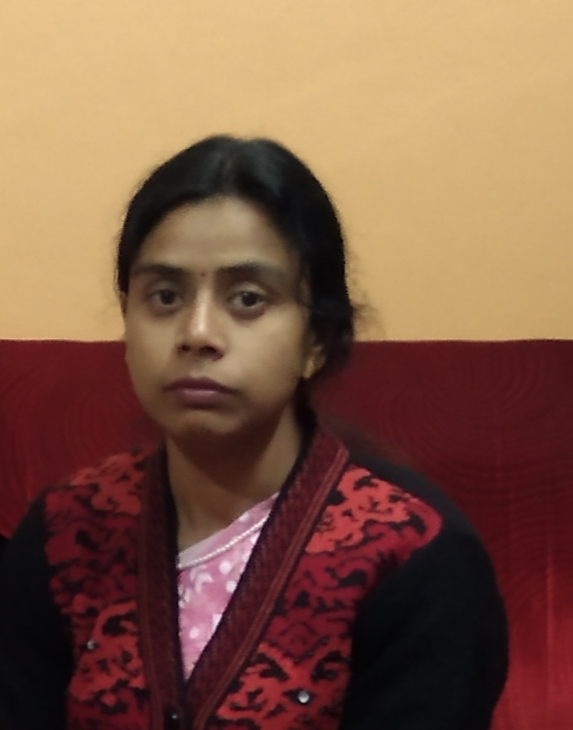
Name: Jaya Mukherjee

Designation: SACT
Date of Joining: 02/08/2017
e-mail: jayachatterjee21@gmail.com

Educational Qualification:
- Graduation: B.A pass 2007
- Post-graduation: M.A 2014
- M.Phil / Ph.D.

State Level / National / International Conferences /Seminars /Workshops /Webinar Attended:
- Paper Presentations in Seminars / Conferences / Webinars
- NA

- Participation in Seminars / Conferences / Training Programmes / Workshop / Webinars
- Management of Anxiety through Education 26th September 2020

List of Research Papers published in National / International Journals / Books / Conference Proceedings with ISBN / ISSN / Impact Factor:
- Books:
- NA
B)Journals:
1. NA
C)Conference Proceedings:
1. NA

Awards and Recognition:
- NA

Areas of Specialization in Research / Teaching:
- Specialization in Teaching: Social Education

- In Research: NA

Teaching:
- Theory: Education Theory, Social Education
- Practical: NA
- Excursion / Field Survey: NA

Invited Lecture / Foreign Visit:
1. NA

Other Academic Activities:

- Board of Studies: NA
- Course Design: NA
- Paper Setter: NA

Administrative Activities:

1. NA

Associated with Learned Bodies / Association / Society / Organization:

1. NA

